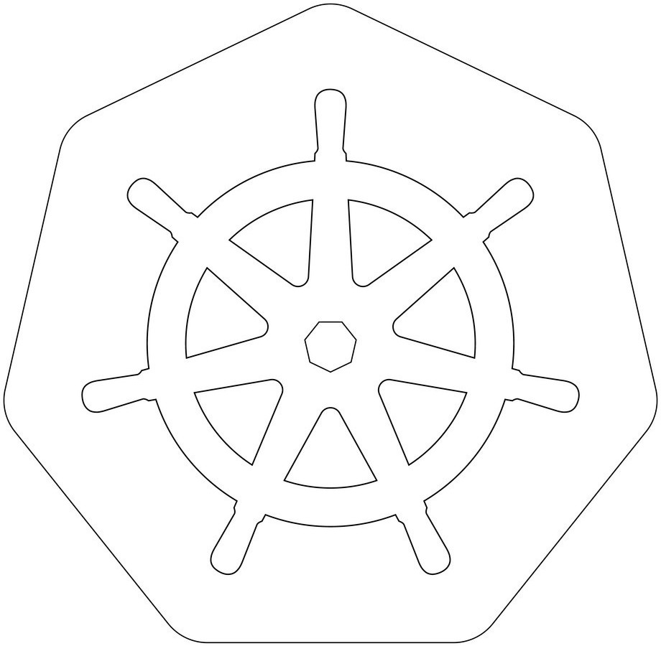

KUBERNETES:

*K U B E R N E T E S K 8S*

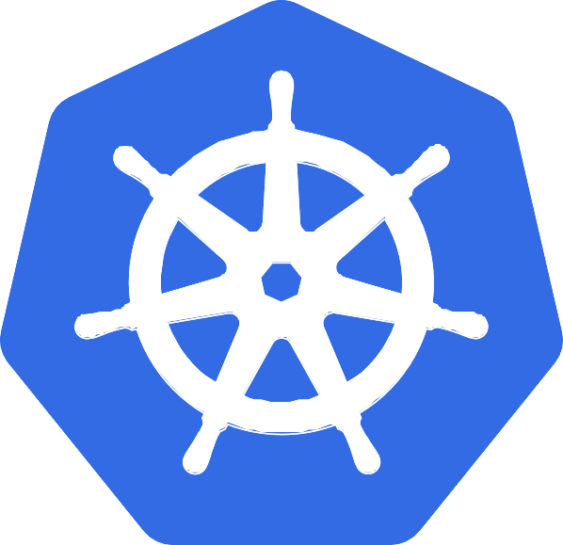



KUBERNETES:

IT is an [open-source](https://www.redhat.com/en/topics/open-source/what-is-open-source) container orchestration platform.

It is us[ed to automat](https://www.redhat.com/en/topics/open-source/what-is-open-source)es many of the manual processes like deploying, managing, and scaling containerized applications.

Kubernetes was developed by GOOGLE using GO Language. Google donated K8's to CNCF in 2014.

1st version was released in 2015.

why KUBERNETES:

Containers are a good and easy way to bundle and run your applications. In a production environment, you need to manage the containers that run the applications and ensure that there is no downtime. In docker we used docker swarm for this. but any how docker has drawbacks!

so we moved to KUBERNETES.

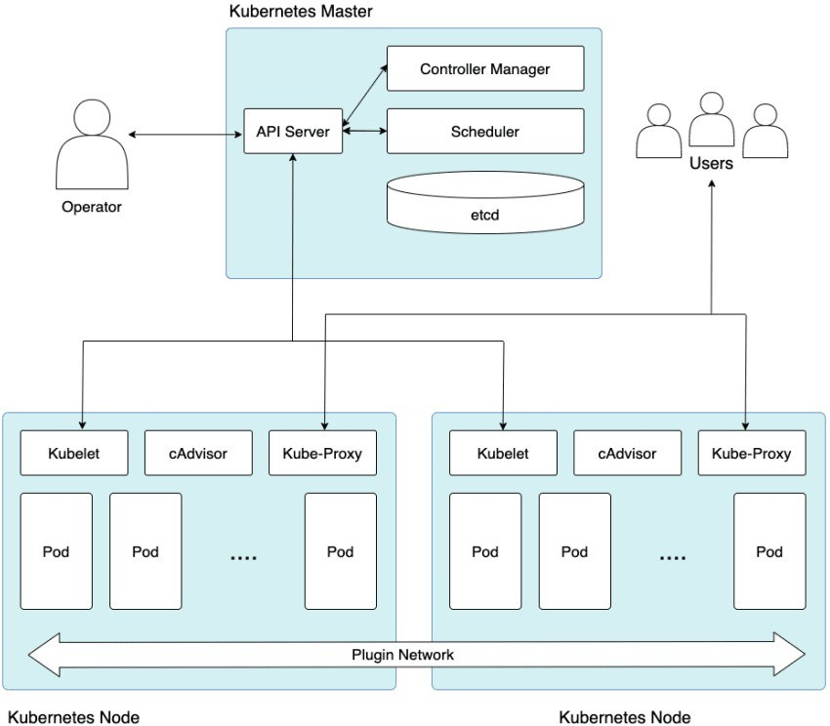

aechitecture:

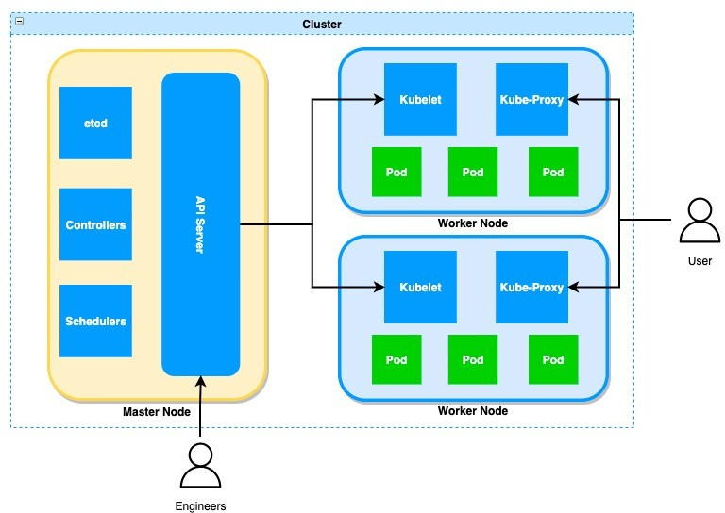cluster:

It is a group of servers It will have both manager and worker nodes.

Master Node is used to assign tasks to Worker Nodes.

Worker node will perform the task.

we have 4 components in Master Node

1.API Server 2.ETCD

3. Controllers-manager

4. Schedulers

we have 4 components in Worker Node.

1. Kubelet
2. Kube-Proxy
3. Pod
4. Container

a i server:

It is used to accept the request from the user and store the request in ETCD.

ETCD:

It is like a database to our k8's

it is used to store the requests from API Server in the KEY-VALUE format.

scheduler:

It is used to search pending tasks which are present in ETCD.

If any pending task found in ETCD, it will schedule in worker node.

It will decide in which worker node our task should gets executed. It will decide by communication with the kubelet in worker node

controllers:

It is used to perform the operations which is scheduled by the scheduler. it wil control the containers creation in worker nodes.

kubelet:

Agent ensures that pod is running or not.

kube-roxy

It is used to maintain a network connection between worker and manager nodes.

od:

A group of one or more containers.

container:

It is a virtual machine which does not have any OS. it is used to run the applications in worker nodes.

kubernetes cluster setu :

There are multiple ways to setup kubernetes cluster.

1. SELF MANAGER K8'S CLUSTER

a.mini kube (single node cluster) b.kubeadm(multi node cluster)

c. KOPS

1. CLOUD MANAGED K8'S CLUSTER
   1. AWS EKS
   2. AZURE AKS
   3. GCP GKS
   4. IBM IKE

## WHY KUBERNETES

Earlier We used Docker Swarm as a container orchestration tool that we used to manage multiple containerized applications on our environments.

|  |  |  |
| --- | --- | --- |
| **FEATURES** | **DOCKER SWARM** | **KUBERNETES** |
| Setup  Auto Scaling Community  GUI | Easy  No Auto Scaling Good Community  No GUI | Complex  Auto Scaling  Greater community for users like documentation, support and resources  GUI |



## MINIKUBE:

It is a tool used to setup single node cluster on K8's.

It contains API Servers, ETDC database and container runtime It helps you to containerized applications.

It is used for development, testing, and experimentation purposes on local.

Here Master and worker runs on same machine It is a platform Independent.

By default it will create one node only.

Installing Minikube is simple compared to other tools. NOTE: But we dont implement this in real-time

## MINIKUBE SETUP:

**REQUIREMENTS:**

2 CPUs or more

2GB of free memory 20GB of free disk space Internet connection

Container or virtual machine manager, such as: [Docker](https://minikube.sigs.k8s.io/docs/drivers/docker/).

***UPDATE SERVER:***

1. apt update -y
2. apt upgrade -y

***INSTALL DOCKER:***

1. sudo apt install curl wget apt-transport-https -y
2. sudo curl -fsSL https://get.docker.com -o get-docker.sh sudo sh get-docker.sh

***INSTALL MINIKUBE:***

1. sudo curl -LO https://storage.googleapis.com/minikube/releases/latest/minikube-linux-amd64
2. sudo mv minikube-linux-amd64 /usr/local/bin/minikube
3. sudo chmod +x /usr/local/bin/minikube
4. sudo minikube version

***INSTALL KUBECTL:***

1. sudo curl -LO "https://dl.k8s.io/release/$(curl -L -s https://dl.k8s.io/release/stable.txt)/bin/linux/amd64/kubectl"
2. sudo curl -LO "https://dl.k8s.io/$(curl -L -s https://dl.k8s.io/release/stable.txt)/bin/linux/amd64/kubectl.sha256"
3. sudo echo "$(cat kubectl.sha256) kubectl" | sha256sum --check
4. sudo install -o root -g root -m 0755 kubectl /usr/local/bin/kubectl
5. sudo kubectl version --client
6. sudo kubectl version --client --output=yaml
7. sudo minikube start --driver=docker --force

## KUBECTL:

kubectl is the CLI which is used to interact with a Kubernetes cluster. We can create, manage pods, services, deployments, and other resources We can also monitoring, troubleshooting, scaling and updating the pods. To perform these tasks it communicates with the Kubernetes API server. It has many options and commands, to work on.

The configuration of kubectl is in the $HOME/.kube directory. The latest version is 1.27

***SYNTAX:***

kubectl [command] [TYPE] [NAME] [flags] kubectl api-resources : to list all api resources

## POD:

It is a smallest unit of deployment in K8's. It is a group of containers.

Pods are ephemeral (short living objects)

Mostly we can use single container inside a pod but if we required, we can create multiple containers inside a same pod.

when we create a pod, containers inside pods can share the same network namespace, and can share the same storage volumes .

While creating pod, we must specify the image, along with any necessary configuration and resource limits.

K8's cannot communicate with containers, they can communicate with only pods.

We can create this pod in two ways,

1. Imperative(command)
2. Declarative (Manifest file)

## POD CREATION:

IMPERATIVE:

The imperative way uses kubectl command to create pod.

This method is useful for quickly creating and modifying the pods. SYNTAX: kubectl run pod_name --image=image_name COMMAND: ***kubectl run pod-1 --image=nginx***

***kubectl : command line tool run : action pod-1 : name of pod***

***nginx : name of image***

## KUBECTL:

DECLARATIVE:

The Declarativ tive way we need to create a Manifest file in YAML Extension. This file contains the desired state of a Pod.

It takes care of creating, updating, or deleting the resources. This manifest file need to follow the yaml indentation.

YAML file consist of KEY-VALUE Pair.

Here we use create or apply command to execute the Manifest file.

SYNTAX: kubectl create/apply -f file_name

CREATE: if you are creating the object for first time we use create only.

APPLY: if we change any thing on files and changes need to apply the resources.

## KUBECTL: MANIFEST FILE:

##### apiVersion: Kind: Metadata: Spec: Name Image Ports

For communicating with master node it is a type of resource

data about pod

it is a specifications of a container

: Name of the Container

: Conatiner image

: To Expose the Application

- : It is called as Array

## COMMANDS:

To get all the pods: kubetctl get pods (or) kubectl get pod (or) kubectl get po

To delete a pod: kubectl delete pod pod_name

To get IP of a pod: kubectl get po pod_name -o wide

To get IP of all pods: kubectl get po -o wide

To get all details of a pod: kubectl describe pod podname

To get all details of all pods: kubectl describe po

To get the pod details in YAML format: kubectl get pod pod-1 -o yaml To get the pod details in JSON format: kubectl get pod pod-1 -o json To enter into a pod: kubectl exec -it pod_name -c cont_name bash To get the logging info of our pod: kubectl logs pod_name

To get the logs of containers inside the pod: kubectl logs pod_name -c cont-name

## WE DEPLOYED THE POD



**LETS ACCESS OUR APPLICATION**



**I CANT ABLE TO ACCESS MY APPLICATION**

The reason why we are not able to access the application: In Kubernetes, if you want to access the application we have to expose our pod. To Expose these pods we use Kubernetes services.

## KUBERNETES SERVICES

Service is a method for exposing [Pods](https://kubernetes.io/docs/concepts/workloads/pods/) in your cluster.

Each Pod gets its own IP address But we need to access from IP of the Node.. If you want to access pod from inside we use Cluster-IP.

If the service is of type NodePort or LoadBalancer, it can also be accessed. from outside the cluster.

It enables the pods to be decoupled from the network topology, which makes it easier to manage and scale applications

## TYPES:

**CLUSTER-IP NODE PORT LOAD BALANCER**

## TYPES OF SERVICES

ClusterIP: A ClusterIP service provides a stable IP address and DNS name for pods within a cluster. This type of service is only accessible within the cluster and is not exposed externally.

NodePort: A NodePort service provides a way to expose a service on a static port on each node in the cluster. This type of service is accessible both within the cluster and externally, using the node's IP address and the NodePort.

LoadBalancer: A LoadBalancer service provides a way to expose a service externally, using a cloud provider's load balancer. This type of service is typically used when an application needs to handle high traffic loads and requires automatic scaling and load balancing capabilities.

ExternalName: An ExternalName service provides a way to give a service a DNS name that maps to an external service or endpoint. This type of service is typically used when an application needs to access an external service, such as a database or API, using a stable DNS name.

## COMPONENTS OF SERVICES

A service is defined using a Kubernetes manifest file that describes its properties and specifications. Some of the key properties of a service include:

Selector: A label selector that defines the set of pods that the service will route traffic to.

Port: The port number on which the service will listen for incoming traffic. TargetPort: The port number on which the pods are listening for traffic.

Type: The type of the service, such as ClusterIP, NodePort, LoadBalancer, or ExternalName.

## CLUSTER-IP:

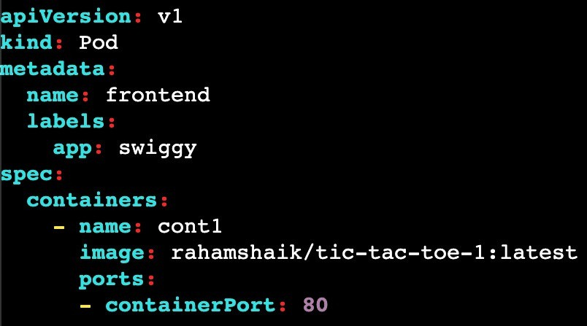

To deploy the application we create a container, which stores inside the pod. After container is created we will be not able to access the application.

Because we cannot access the pods and ports from the cluster. To Avoid this we are creating the Services.

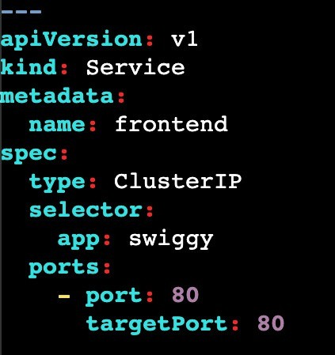In this code we are exposing the applcation. here we use clusterip service

By using this we can access application inside the cluster only.

But if we want to access the application from outside we need to use nodeport.

ClusterIP will assign one ip for service to access the pod.

Just Replace ***ClusterIP=NodePort***

kubectl apply -f filename.yml

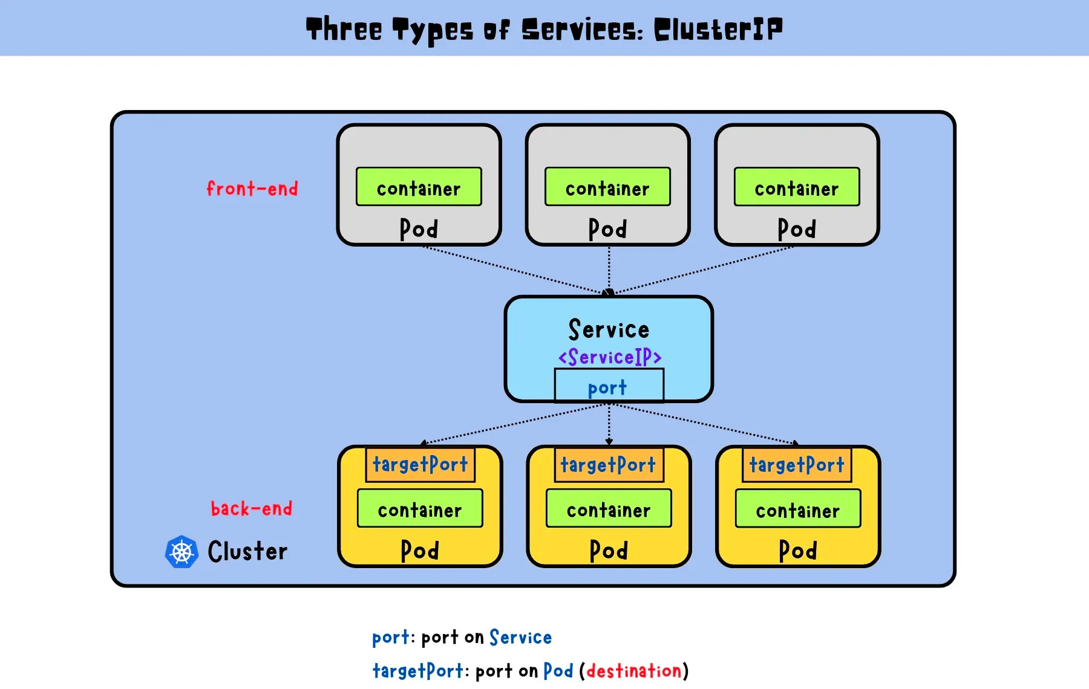

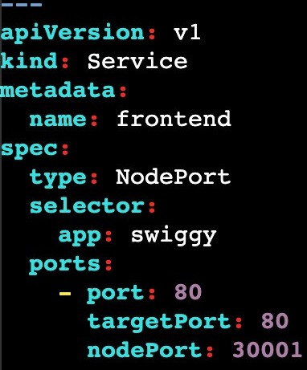In this code we are exposed the application from anywhere (inside & outside)

We need to Give public ip of node where pod is running.

Node Port Range= 30000 - 32767

here i hae defined port number as 30001

if we dont specify the port it will assign automatically. kubectl apply -f filename.yml.

NodePort expose service on a static port on each node. NodePort services are typically used for smaller applications with a lower traffic volume.

To avoid this we are using the LoadBalancer service.

Just Replace ***NodePort=LoadBalancer***

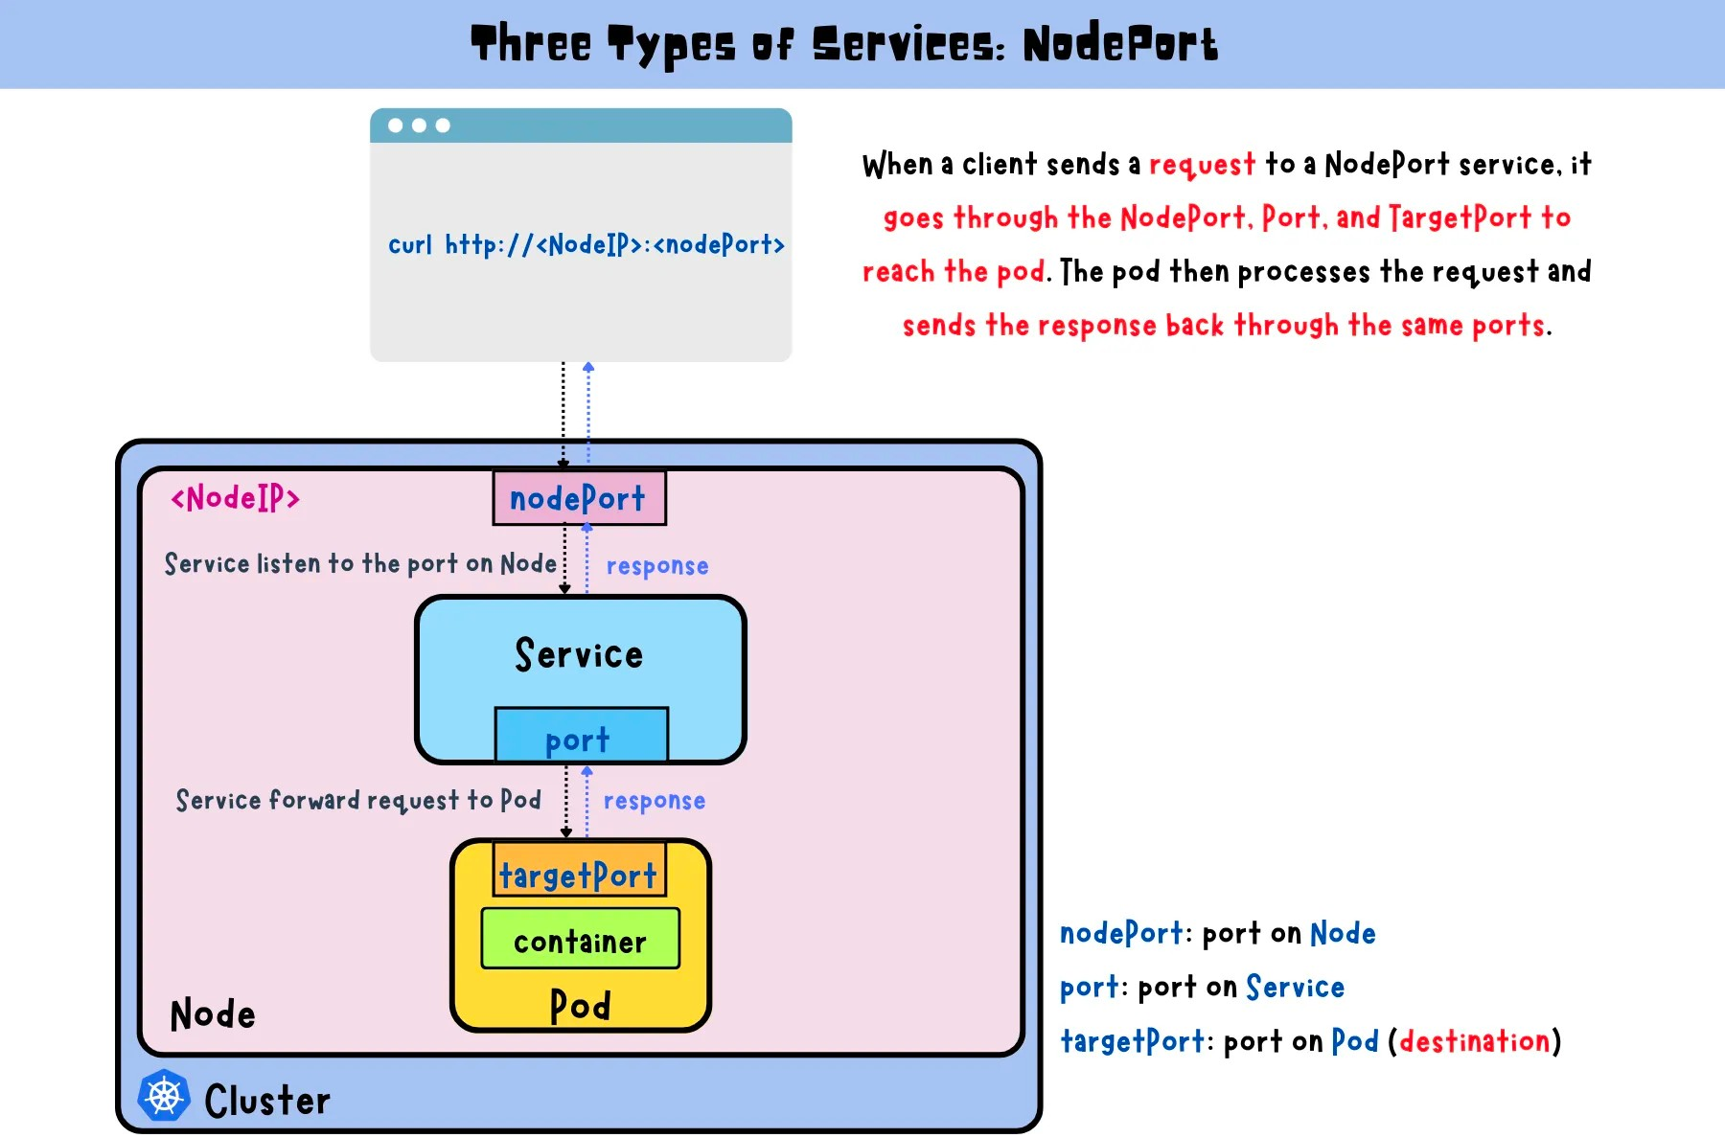

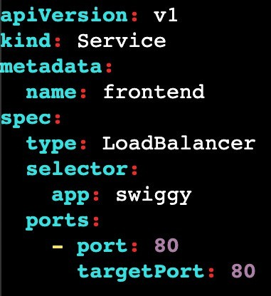In LoadBalaner we can expose application externally with the help of Cloud Provider LoadBalancer.

it is used when an application needs to handle high traffic loads and requires automatic scaling and load balancing capabilities.

After the LoadBalancer service is created, the cloud provider will created the Load Balancer.

This IP address can be used by clients outside the cluster to access the service.

The LoadBalancer service also automatically distributes incoming traffic across the pods that match the selector defined in the YAML manifest.

access : publicip:port and LB url [http://a0dce056441c04035918de4bfb5bff97-40528368.us-](http://a0dce056441c04035918de4bfb5bff97-40528368.us-/) east- 1.elb.amazonaws.com/

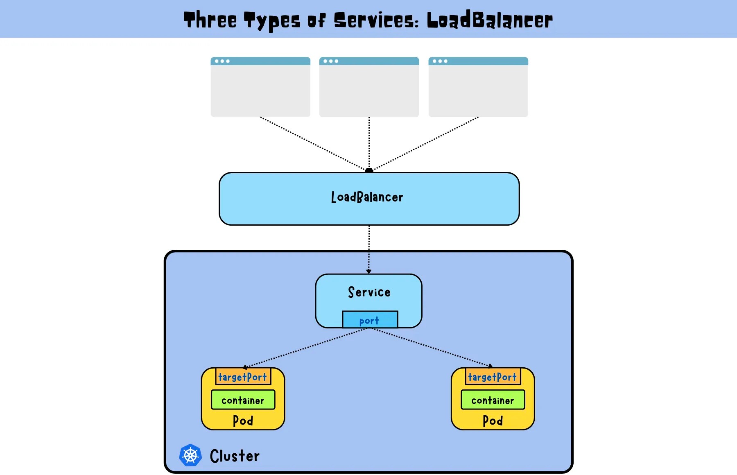

# THE DRAWBACK

In the above both methods we can be able to create a pod but what if we delete the pod ?

once you delete the pod we cannot able to access the pod, so it will create a lot of difficulty in Real time

##### NOTE: Self healing is not Avaliable here.

To overcome this on we use some Kubernetes components called RC, RS, DEPLOYMENTS, DAEMON SETS, etc ...

## COMMANDS FOR SERVICES:

1. Creates a new service based on the YAML file

kubectl create -f filename

1. Create a ClusterIP service

kubectl create service clusterip <service-name> --tcp=<port>:<targetPort>

1. Create a NodePort service

kubectl create service nodeport <service-name> --tcp=<port>:<targetPort>

--node-port=<nodePort>

1. Create a LoadBalancer service

kubectl create service loadbalancer <service-name> --tcp=<port>:<targetPort>

1. Create a service for a pod

kubectl expose pod <pod-name> --name=<service-name> \

--port=<port> --target-port=<targetPort> --type=<service-type>

1. Create a service for a deployment

kubectl expose deployment <deployment-name> --name=<service-name> \

--port=<port> --target-port=<targetPort> --type=<service-type>

1. Retrieve a list of services that have been created

kubectl get services

1. Retrieve detailed information about a specific service

kubectl describe services <service-name>

## REPLICATION CONTROLLER:

Replication controller can run specific number of pods as per our requirement.

It is the responsible for managing the pod lifecycle

It will make sure that always pods are up and running.

If there are too many pods, RC will terminates the extra pods. If there are two less RC will create new pods.

This Replication controller will have slef-healing capability, that means automatically it will creates.

If a pod is failed, terminated or deleted then new pod will get crated automatically. Replication Controllers use labels to identify the pods that they are managing.

We need to specifies the desired number of replicas in YAML file.

## REPLICATION CONTROLLER:

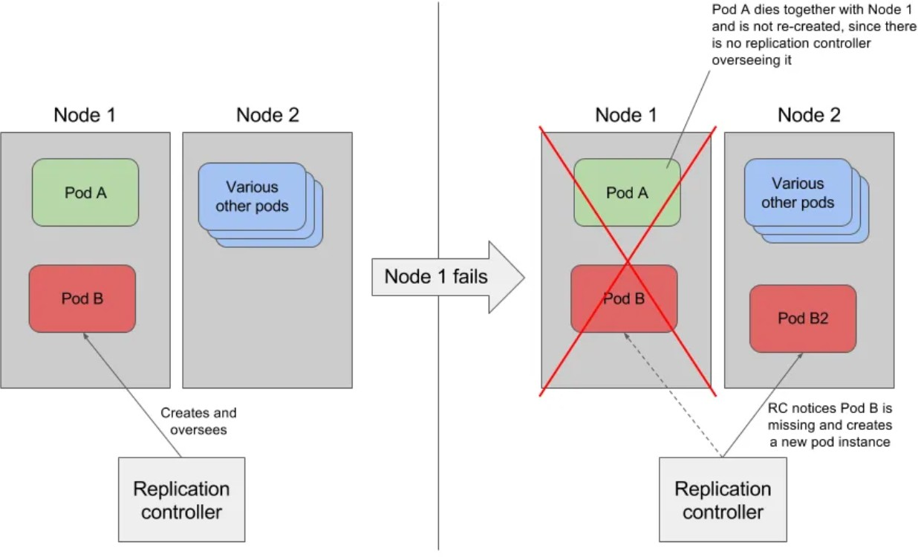

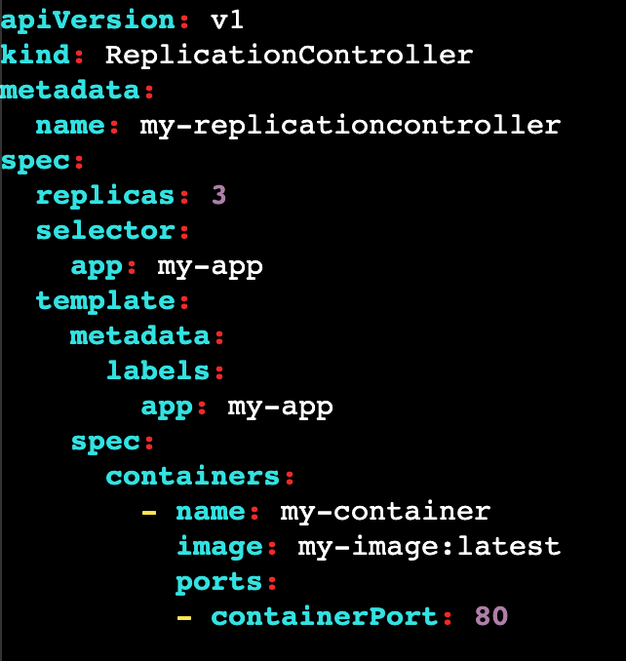*SELECTOR:* It select the resources based on labels. Labels are key value pairs.

This will helps to pass a command to the pods with lable app=nginx

***TO EXECUTE TO GET***

***TO DESCRIBE TO SCALE UP***

***TO SCALE DOWN***

: kubectl create -f file_name.yml

: kubectl get rc

: kubectl describe rc/nginx

: kubectl scale rc rc_name --replicas 5

: kubectl scale rc rc_name --replicas 2 (drops

from 5 to 2)

***TO DELETE REPLICA CONTROLLER***

: kubectl delete rc rc_name

IF WE DELETE RC, PODS ARE ALSO GETS DELETED, BUT IF WE DON’T WANT TO DELETE PODS, WE WANT TO DELETE ONLY REPLICA SETS THEN

kubectl delete rc rc_name --cascade=orphan kubectl get rc rc_name

kubectl get pod

Now we deleted the RC but still pods are present, if we want to assign this pods to another RC use the same selector which we used on the RC last file.

# THE DRAWBACK

RC used only equality based selector ex: env=prod

here we can assign only one value (equality based selector)

We are not using these RC in recent times, because RC is replaced by RS(Replica Set)

## REPLICASET:

it is nothing but group of identical pods. If one pod crashes automatically replica sets gives one more pod immediately.

it uses labels to identify the pods

Difference between RC and RS is selector and it offers more advanced functionality.

The key difference is that the replication controller only supports

##### equality-

*based selectors* whereas the replica set supports

##### set-based selectors.

it monitoring the number of replicas of a pod running in a cluster and creating or deleting new pods.

It also provides better control over the scaling of the pod.

A ReplicaSet identifies new Pods to acquire by using its selector. we can provide multiple values to same key.

ex: env in (prod,test)

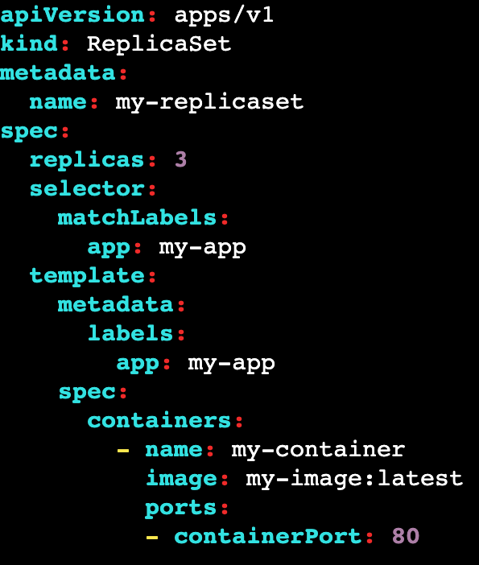Replicas: Number of pod copies we need to create Matchelabel: label we want to match with pods Template: This is the template of pod.

Note: give apiVersion: apps/v1 on top

Labels : mandatory to create RS (if u have 100 pods in a cluster we can inform which pods we need to take care by using labels) if u labeled some pods a raham then all the pods with label raham will be managed.

## COMMANDS:

***TO EXECUTE :***

***TO LIST :***

***TO GET INFO :***

***TO GET IN YAML : TO GET ALL RESOURCES :***

kubectl create -f replicaset-nginx.yaml kubectl get replicaset/rs

kubectl get rs -o wide kubectl get rs -o yaml kubectl get all

***Now delete a pod and do list now it will be created automatically***

***TO DELETE A POD :***

***TO DELETE RS : TO SHOW LABLES OF RS : TO SHOW POD IN YAML :***

Kubectl delete po pod_name kubectl delete rs

Kubectl get po –show-labels Kubectl get pod -o yaml

# THE DRAWBACK

Here Replica set is an lower level object which focus on maintaining desired number of replica pods.

To manage this replica set we need a higher-level object called deployment which provide additional functionality like rolling updates and roll backs.

Deployments use ReplicaSets under the hood to manage the actual pods that run the application.

## DEPLOYMENT:

It has features of Replicaset and some other extra features like updating and rollbacking to a particular version.

The best part of Deployment is we can do it without downtime.

you can update the container image or configuration of the application. Deployments also provide features such as versioning, which allows you to track the history of changes to the application.

It has a pause feature, which allows you to temporarily suspend updates to the application

Scaling can be done manually or automatically based on metrics such as CPU utilization or requests per second.

Deployment will create ReplicaSet, ReplicaSet will created Pods.

If you delete Deployment, it will delete ReplicaSet and then ReplicaSet will delete Pods.

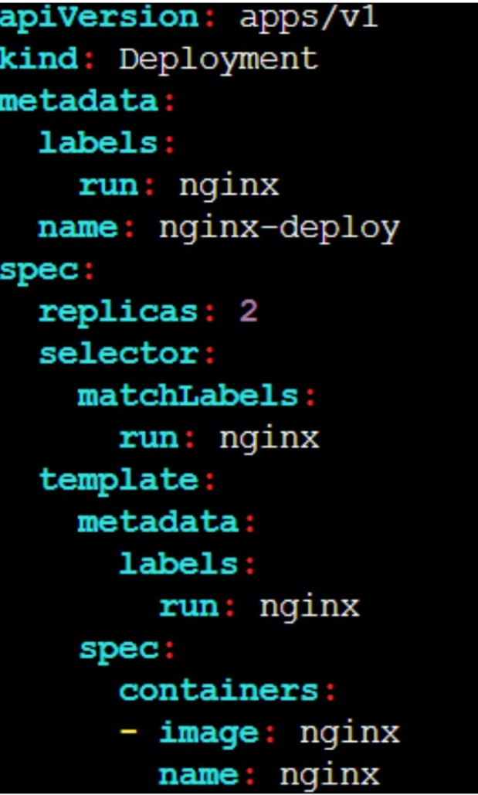

Replicas: Number of pod copies we need to create Matchelabel: label we want to match with pods Template: This is the template of pod.

Labels : mandatory to create RS (if u have 100 pods in a cluster we can inform which pods we need to take care by using labels) if u labeled some pods a raham then all the pods with label raham will be managed.

## MANIFEST FILE:

To create a replica set : kubectl create -f replicaset-nginx.yaml To see a deployment : kubectl get deployment/deploy

To see full details of deployment : kubectl get deploy -o wide To view in YAML format : kubectl get deploy -o yaml

To get all info : kubectl describe deploy

## COMMAND TO CREATE DEPLOYMENT:

##### kubectl create deployment deployment-name --image=image-name --replicas=4

***Now delete a pod and do list now it will be created automatically***

To delete a pod: Kubectl delete po pod_name To check logs : kubectl logs pod_name

To delete a deployment : kubectl delete deploy deploy_name

When you inspect the Deployments in your cluster, the following fields are displayed:

*NAME* lists the names of the Deployments in the namespace.

*READY* displays how many replicas of the application are available to your users. It follows the pattern ready/desired.

*UP*-TO-DATE displays the number of replicas that have been updated to

achieve the desired state.

*AVAILABLE* displays how many replicas of the application are available to your users.

*AGE* displays the amount of time that the application has been running.

## UPDATING A DEPLOYMENT:

##### update the container image:

kubectl set image deployment/deployment-name my-container=image-name or

kubectl edit deployment/deployment-name

##### To roll back:

kubectl rollout status deployment/deployment-name

##### To check the status:

kubectl rollout status deployment/deployment-name

##### To get the history:

kubectl rollout history deployment/deployment-name

##### To rollback specific version:

kubectl rollout undo deployment/deployment-name --to-revision=number

## PAUSE/UNPAUSE A DEPLOYMENT:

##### To pause a pod in deployment:

kubectl rollout pause deployment/deployment-name

##### To un-pause a pod in deployment:

kubectl rollout resume deployment/deployment-name

## DEPLOYMENT SCALING:

Lets assume we have 3 pods, if i want to scale it to 10 pods (manual scaling) kubectl scale deployment/nginx-deployment --replicas=10

Assume we have HPA(Horizontal POD Auto-scaling) enabled in cluster.

So if we want to give the min and max count of replicas

kubectl autoscale deployment/nginx-deployment --min=10 --max=15 Now if we want to assign cpu limit for it

kubectl autoscale deployment/nginx-deployment --min=10 --max=15 --cpu- percent=80

Manual scaling means we can define the replicas (--repicas=5) HPA automatically scale the replicas based on cpu metrics

## DEPLOYMENT SCALING:

Now run kubectl get rs : you will get the new deployment. kubectl get pod

You see that the number of old replicas is 3, and new replicas is 0. Next time you want to update these Pods, you only need to update the Deployment's Pod template again.

While updating pods, 75% will be available and 25% will be unavailable during updates

Lets assume, if we have 4 pods, while trying to update them atleast 3 of them are available and 1 should be updated in the mean time.

## DAEMON-SET:

It is used to run a copy a pod to worker node.

It is used to perform some tasks like monitoring, Log collection etc.. that need to run on every node of the cluster.

A DaemonSet ensures that all eligible nodes run a copy of a Pod

When you create daemon set k8s schedules one copy of pod in each node. If we added new node it will copy the pod automatically to new node.

If I remove on node from cluster the pod in that node also removed. Deleting a DaemonSet will clean up the Pods it created.

A Pod Template in a DaemonSet must have a RestartPolicy equal to Always, or be unspecified, which defaults to Always.

Daemon sets will not used for deployments on real-time, it is only to schedule pods.

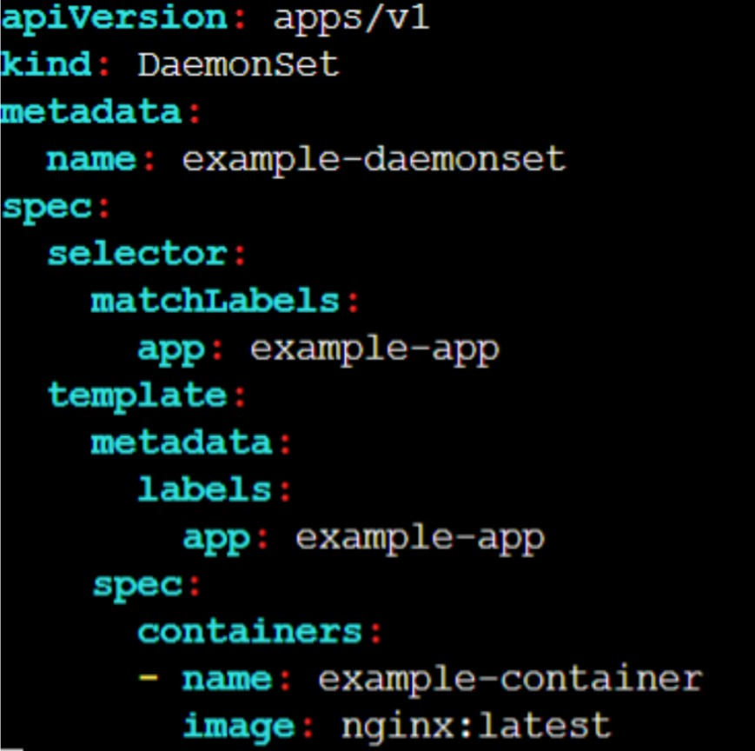

## MANIFEST FILE:

TO EXECUTE : kubectl create -f replicaset-nginx.yaml

TO LIST : kubectl get replicaset/rs

TO GET INFO : kubectl get rs -o wide TO GET IN YAML : kubectl get rs -o yaml TO GET ALL RESOURCES : kubectl get all

Now delete a pod and do list now it will be created automatically TO DELETE A POD. : Kubectl delete po pod_name

TO DELETE RS : kubectl delete rs

TO SHOW LABLES OF RS : Kubectl get po –show-labels

TO SHOW POD IN YAML :Kubectl get pod -o yaml

## NAMESPACE:

Namespaces are used to group the components like pods, services, and deployments.

This can be useful for separating environments, such as development, staging, and production, or for separating different teams or applications.

In real-time all the frontend pods are mapped to one namespace and backend pods are mapped to another namespace.

It represents the cluster inside the cluster.

You can have multiple namespaces within one Kubernetes cluster, and they are all logically isolated from one another.

Namespaces provide a logical separation of cluster resources between multiple users, teams, projects, and even customers.

Within the same Namespace, Pod to Pod communication.

Namespaces provide a logical separation between the environments (Dev, QA, Test, and Prod) with many users, or projects.

Namespaces are only hidden from each other but are not fully isolated from each other.

One service in a Namespace can talk to another service in another Namespace if the target and sources are used with the full name which includes service/object name followed by Namespace.

The name of resources within one namespace must be unique. When you delete a namespace all the resources will gets deleted.

kubectl get namespaces : To get the name space

NAME STATUS AGE default Active 31m kube-public Active 31m kube-system Active 31m

*Default* : when we create resources like pod, service, deployements all will gets stored in default namespace

*kube-public* : The namespace for resources that are publicly available by all.

*kube-system*: The namespace for objects created by the Kubernetes system. *kube-node-lease*: It is used for the lease objects associated with each node that improves the performance of the node heartbeats as the cluster scales

## COMMANDS:

kubectl get ns : ***used to get namespaces***

kubectl create ns mustafa : ***used to create new namespace***

kubectl config set-context --current --namespace=mustafa : ***to check to namespace***

kubectl config view --minify | grep namespace :

***to verify the name space.***

#### CREATE A POD IN NS (IMPERATIVE):

1. *Create a namespace -* kubectl create namespace mustafa
2. *create a pod in ns -* kubectl run nginx --image=nginx --namespace mustafa (or)

kubectl run nginx --image=nginx -n development

1. *To check the pods:* kubectl get pod -n mustafa (0r)

kubectl get pod --namespace mustafa

#### CREATE A POD IN NS (DECLARATIVE):

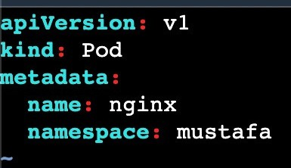

When you delete a namespace all the resources will gets deleted.

kubectl get pods -n mustafa :

##### used to get pods from namespace

kubectl describe pod nginx -n development : ***describe a pod in namespace***

kubectl delete pod nginx -n development :

***delete a pod in namespace***

***POD FILE NODEPORT FILE***

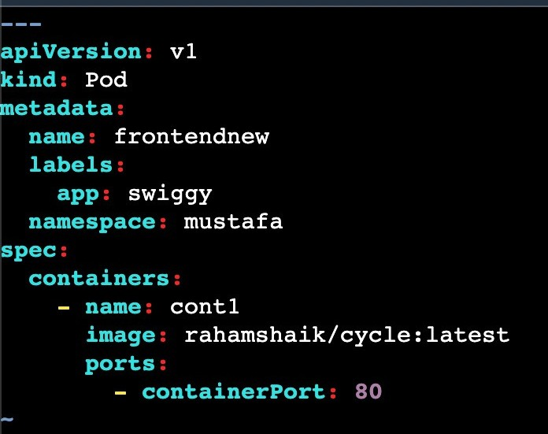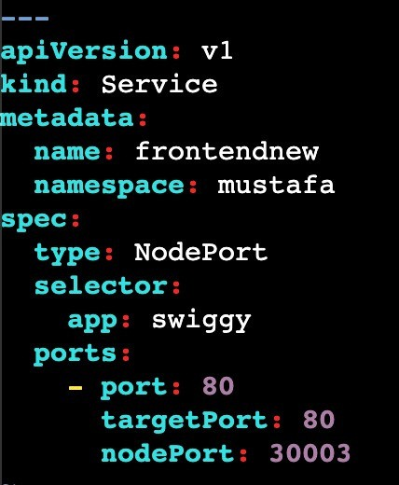

Before going to deploy this file we need to create mustafa namespace. Here i just mentioned namespace in normal manifest file

## CONFIG MAPS:

It is used to store the data in key-value pair, files, or command-line arguments that can be used by pods, containers and other resources in cluster But the data should be non confidential data ()

Here we can set the configuration of data of application seperately It decouple environment specific configuration.

But it does not provider security and encryption.

If we want to provide encryption use secrets in kubernetes.

Limit of config map data in only 1 MB (we cannot store more than that) But if we want to store a large amount of data in config maps we have to mount a volume or use a seperate database or file service.

## USE CASES IN CONFIG MAPS:

Configure application settings: By using this config maps, we can store the configuration data that helps to run our application like database connections and environment variables

Configuring a pod or container: It is used to send a configuration data to a pod or

container at runtime like CLI or files.

Sharing configuration data across multiple resources: By using this configuration data multiple resources can access, such as a common configuration file for different pods or services.

We can store the data: By using this config maps, we can store the data like IP

address, URL's and DNS etc...

Create file that will be the input to our ConfigMap:

cat config-map-data.txt key1=value1

key2=23

command to create config map:

kubectl create configmap configmap-name --from-file=./config-map-data.txt To descibe: kubectl describe configmap/configmap-name

To delete: kubectl delete configmap/configmap

## CREATING A CONFIG MAP:

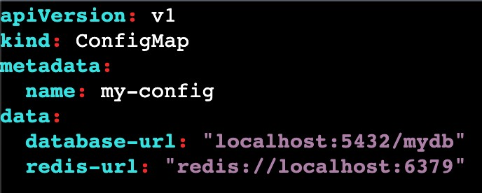

CONF.YML

Create config file and execute it

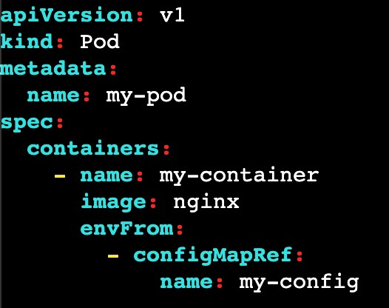

POD.YML

kubectl apply -f conf.yml Create a file for pod and execute it Inside the pod.yml we have to declare our configmap name kubectl apply -f pod.yml

There are 2 possible ways to store the data in config maps

DATA BINARY DATA



Stores data in plain text

used to store configuration, script and other text based data

Encoded in UFT-8 format Decoding in not necessary

Stores data in binary data

stores non-text data like images, videos or binary files

Encoded in BASE-64 format

Here you need to decode data from BASE-64 format before using

## STATELESS APPLICATION



Last night i had a call with mobile customer care, and i explained my issue

with her and requested to resolve the issue. She asked to stay on call for some time. Meanwhile the call was dropped due to network issues

 

Again i called to same number, but this time another person pick the call. He don't know what the conversation we had with the first person. Again i had to repeat the details of my problem to the second person, though it is an inconvenience but it still works out

Kubernetes Deployment suits perfectly here. Let’s assume you deployed your stateless application as a Deployment with 10 Pod replicas running in multiple worker nodes.



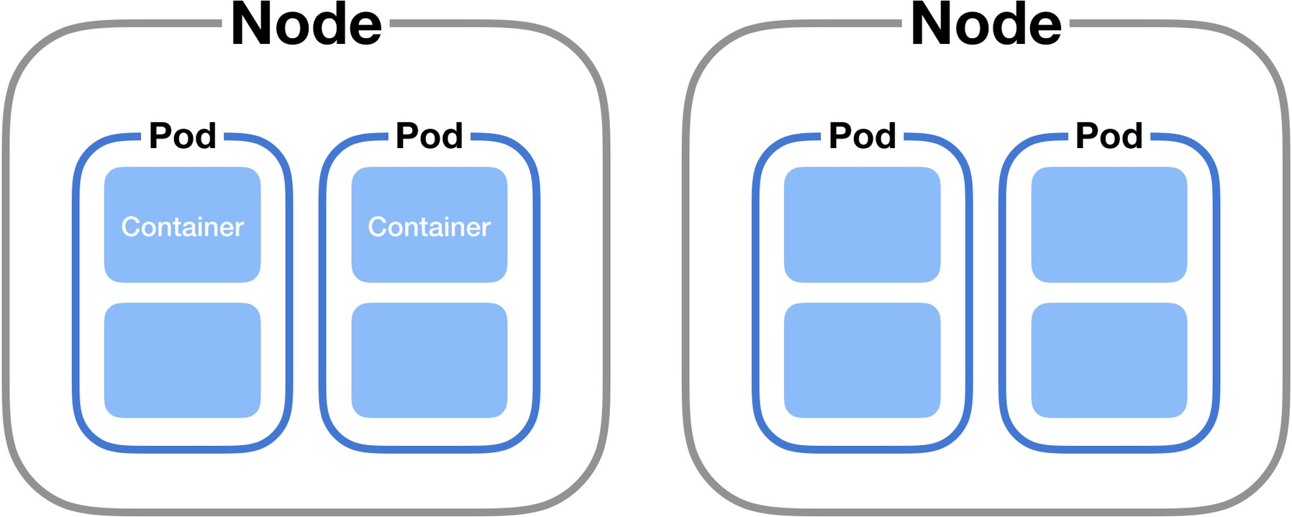

If one of those Pods running in a particular worker node got terminated due to some issue



The ReplicaSet Controller takes care of replacing the bad Pod with a new healthy Pod either on the same node or on a different node.

Here replicaSet's will only take care of those 10 pods are running in the cluster or not.

It doesn't take care of in which worker node they are running!

If pod 1 got terminated from node 1, then new pod will gets replaced on either node 2 or node 1 or anywhere in the cluster.

This is possible because, the stateless application Pod 1 hasn’t stored any data on worker node 1, hence can be easily replaced by new pod running on a different worker node 2

If the pod is not storing the data then we called it as STATELESS

**STATELESS APPLICATION:**

It can't store the data permanently.

The word STATELESS means no past data.

It depends on non-persistent data means data is removed when Pod, Node or Cluster is stopped.

Non-persistent mainly used for logging info (ex: system log, container log etc..) In order to avoid this problem, we are using stateful application.

A stateless application can be deployed as a set of identical replicas, and each replica can handle incoming requests independently without the need to coordinate with other replicas.





Let’s say you want to order some some products in Amazon, you added some products to your shopping cart. After you added the book(s) to your shopping cart, If forgot to switch off the stove in kitchen and you closed the web browser hurry.



Well, you can anytime re-login to amazon portal and resume from where you left last time, as the amazon portal will ensure all items added to the Shopping cart are persisted in database.

Technically, if Amazon is using a ShoppingCart that runs in a Pod,

When i added some products on my cart that will stores on one pod and after some time when i resumed back to the amazon portal that will shows all the products from the different pod.

The interesting thing to understand here is, the StatefulSet Controller managed to bind the exact same Persistent Volume to two Shopping Cart Pods associated to that customer at two different point of time.

### STATEFUL APPLICATION:

Stateful applications are applications that store data and keep tracking it.

Example of stateful applications:

All RDS databases (MySQL, SQL)

Elastic search, Kafka , Mongo DB, Redis etc… Any applicaiton that stores data

To get the code for stateful application use this link:

https://github.com/devops0014/k8s-stateful-set-application.git

### STATEFUL SET

A StatefulSet is the Kubernetes controller used to run the stateful application as containers (Pods) in the Kubernetes cluster.

StatefulSets assign a sticky identity-an orginal number starting from zero-to each Pod instead of assigning random IDs for each replica Pod.

A new Pod is created by cloning the previous Pod's data. If the previous Pod is in the pending state, then the new Pod will not be created.

If you delete a Pod, it will delete the Pod in reverse order, not in random order.

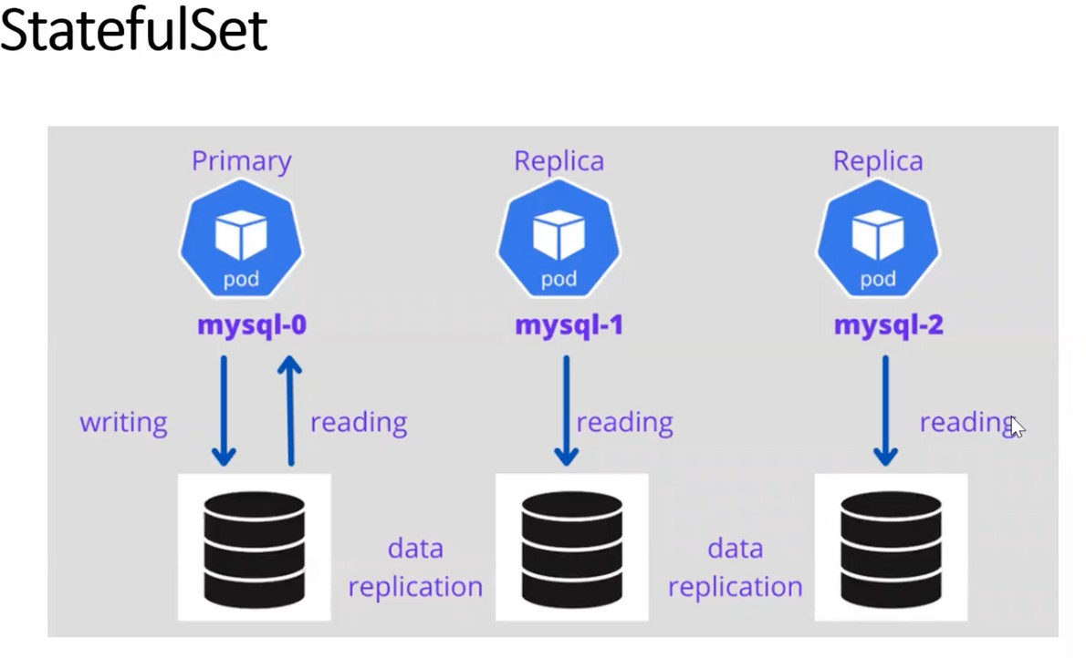

Lets assume we deployed 3 replicas in a node,

1st pod is primary pod, remaining pods are secondary pods. Primary pod is having both read and write access

But secondary pod is having only read access

If we insert some data in primary pod, we can access the data from any pod i.e.. pod will share the data each other

### DEPLOYMENT VS STATEFUL SET

deployment cannot give the numbers or index for resources

but the stateful set will give the sticky identities called index numbers

when we delete pods in stateful set last pod will be deleted first and primary pod deletes last

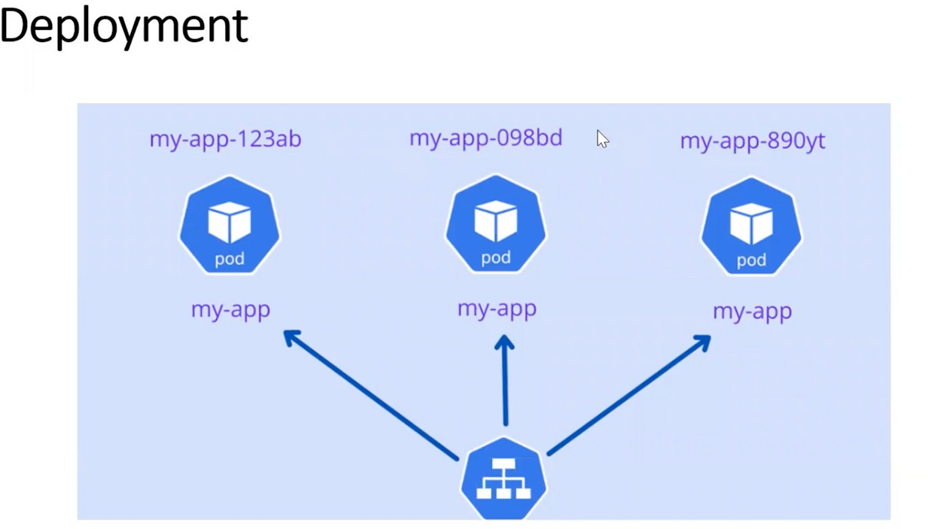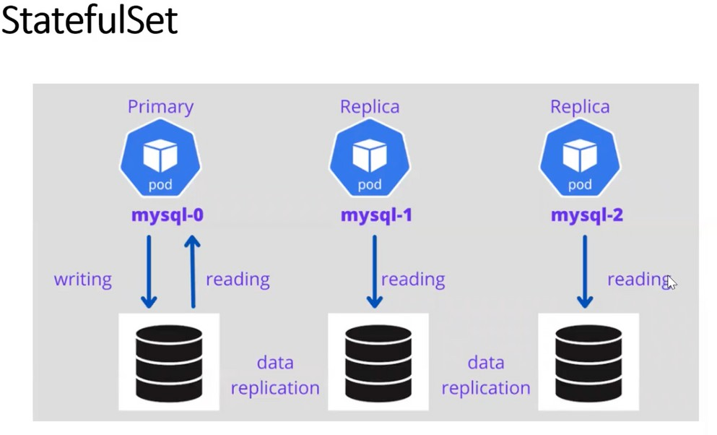

|  |  |
| --- | --- |
| **DEPLOYMENT** | **STATEFUL SET** |
| It will create POD's with random ID's Scale down the POD's in random ID's POD's are stateless POD's  We use this for application deployment | It will create POD's with sticky ID's Scale down the POD's in reverse order POD's are stateful POD's  We use this for database deployment |



## PERSISTENT VOLUME:

Persistent means always available.

PVs are independent of the pod lifecycle, which means they can exist even if no pod is using them.

In K8S, a PV is a piece of storage in the cluster that has been provisioned by an administrator or dynamically created by a storage class.

Once a PV is created, it can be bound to a Persistent Volume Claim (PVC), which is a request for storage by a pod.

When a pod requests storage via a PVC, K8S will search for a suitable PV to satisfy the request.

If a PV is found that matches the request, the PV is bound to the PVC and the pod can use the storage.

If no suitable PV is found, K8S will either dynamically create a new one (if the storage class supports dynamic provisioning) or the PVC will remain unbound.

## PERSISTENT VOLUME CLAIM:

To use Pv we need to claim the volume using PVC.

PVC request a PV with your desired specification (size, access, modes & speed etc) from k8s and onec a suitable PV is found it will bound to PVC

After bounding is done to pod you can mount it as a volume.

once user finished its work the attached PV can be released the underlying PV can be reclaimed & recycled for future.

RESTRICTIONS:

1. Instances must be on same az as the ebs
2. EBS supports only a sinlge EC2 instance mounting

vim pv.yml

apiVersion: v1

kind: PersistentVolume metadata:

name: my-pv spec:

capacity: storage: 10Gi

accessModes:

- ReadWriteOnce awsElasticBlockStore:

volumeID: vol-0e5bdf9400dbb7b57 fsType: ext4

vim pvc.yml

apiVersion: v1

kind: PersistentVolumeClaim metadata:

name: my-pvc spec:

accessModes:

- ReadWriteOnce resources:

requests: storage: 10Gi

kubectl apply -f pv.yml kubectl apply -f pvc.yml kubectl get pv,pvc

vim deploy.yml apiVersion: apps/v1 kind: Deployment metadata:

name: pvdeploy spec:

replicas: 1 selector:

matchLabels:

app: swiggy template:

metadata:

labels:

app: swiggy spec:

containers:

* name: raham image: centos

command: ["bin/bash", "-c", "sleep 10000"] volumeMounts:

* + name: mypd

mountPath: "/tmp/persistent" volumes:

* + name: mypd persistentVolumeClaim:

claimName: my-pvc

kubectl apply -f deploy.yml kubectl get deploy

kubectl get rs kubectl get po

kubectl exec pvdeploy-86c99cf54d-d8rj4 -it -- /bin/bash cd /tmp/persistent/

ls

vim raham exit

now delete the pod and new pod will created then in that pod you will see the same content.